# **Day 2 : Basic Linux commands**

****This is**[#90DaysofDevops](https://www.linkedin.com/feed/hashtag/?keywords=90daysofdevops&highlightedUpdateUrns=urn:li:activity:7015419431497416704" \t "https://medium.com/@misalPav/_blank)**challenge under the guidance of**[Shubham Londhe](https://www.linkedin.com/in/ACoAABhZ4kMBt55axHJpEnVRp0UOUl-_JwwmPwk" \t "https://medium.com/@misalPav/_blank)**sir.****

Day 2 TASK

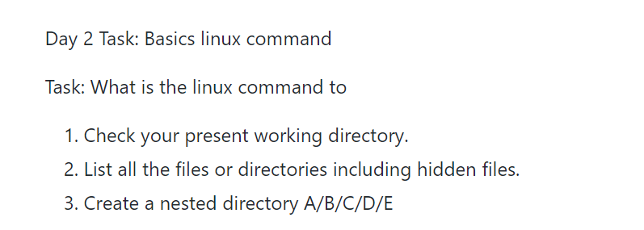

# **What is Linux?**

Linux is a free and open-source operating system (OS) that was created by Linus Torvalds in 1991. It is based on the Unix operating system.

Linux is known for its stability, security, and flexibility.

There are many different versions of Linux, known as “distributions,” each with its own unique features and capabilities. Some of the most popular distributions include Ubuntu, CentOS, and Red Hat Enterprise Linux.

# **Command to use present working directory :**

The “pwd” command stands for “print working directory.” It is used to display the full path of the current working directory.

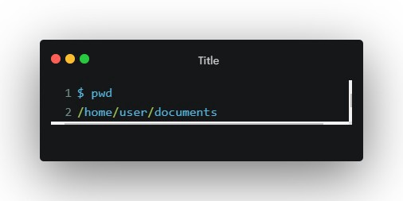

# **Command to list files and directories with hidden files :**

ls is a command that is used to list the files and directories in a directory. The -la option tells ls to display the files in a long format and include hidden files.

#ls -la

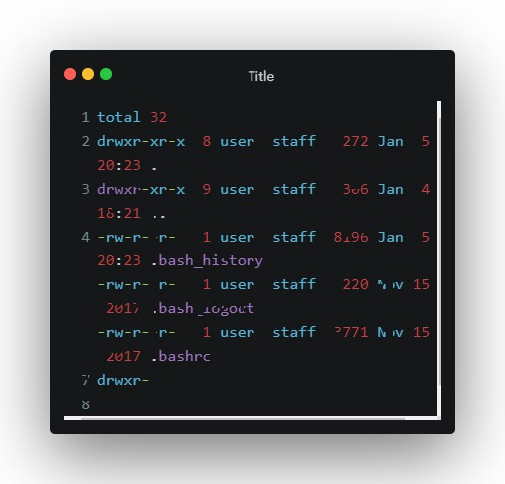

# **Create a nested directory A/B/C/D/E :**

The command to create a nested directory is mkdir -p A/B/C/D/E. The -p switch creates parents’ directories.

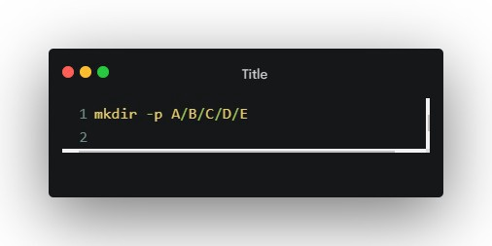

****If this post was helpful, please do follow and click the clap****

****_ Thank you for reading****

****_Rajani****